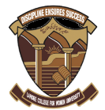
Sustainable Development GOALS
2019
LAHORE COLLEGE FOR WOMEN UNIVERSITY

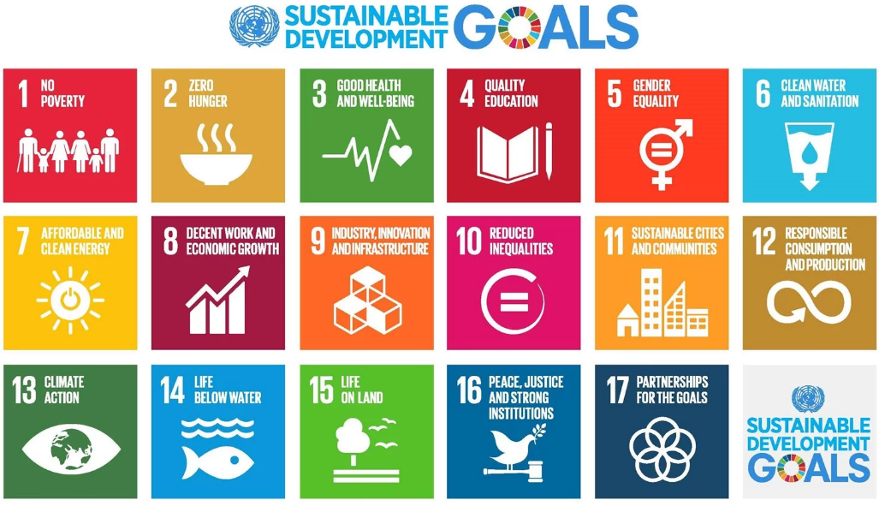

LAHORE COLLEGE FOR WOMEN UNIVERISTY
Sustainable Development GOALS

Lahore College for Women Key Facts
Lahore College for Women University have a clear contribution to each goal through our teaching, research and operations, the top 4 Goals where Lahore College for Women University combined academic work contributes to are: RESEARCH, Public engagement,
SDG 1: No Poverty

Ehsaas Undergraduate scholarship project

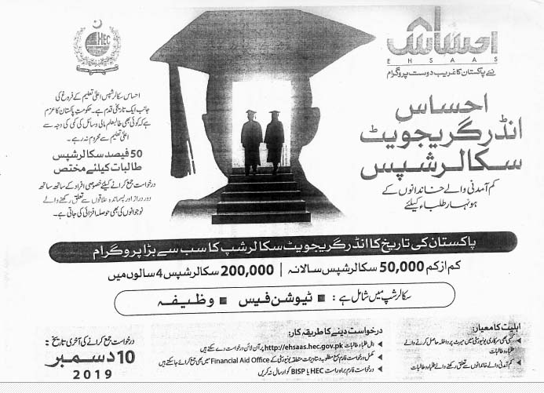
“Ehsaas Undergraduate scholarship project” launched by the HEC with the support of Govt of Pakistan. This information may be disseminated to all low income financially constrained undergraduate students.

Financial Literacy Seminar

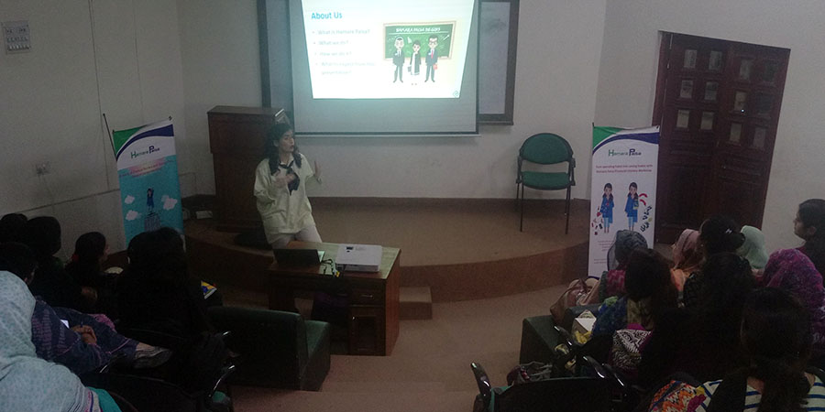

The CCJP arranged a training session on Financial Education on October 21, 2019 in collaboration with Hamara Paisa to train students on how to gain financial independence at an early age. Ms. Sana Imran Co-Founder Hamara Paisa equipped students with vital financial knowledge about importance of saving and investments along with decision making power that resulted in a lasting impact and dictated how they view and manage their finances now and in the future. It was concluded that if Pakistan has a chance to grow and improve, there needs to be a concerted effort to include women into the financial system as early as possible as the future of the economy will rest on their shoulders.

SDG 2: Zero hunger

RIZQ ALLIANCE OF STUDENTS AGAINST POVERTY (ASAP) LCWU PROGRAM

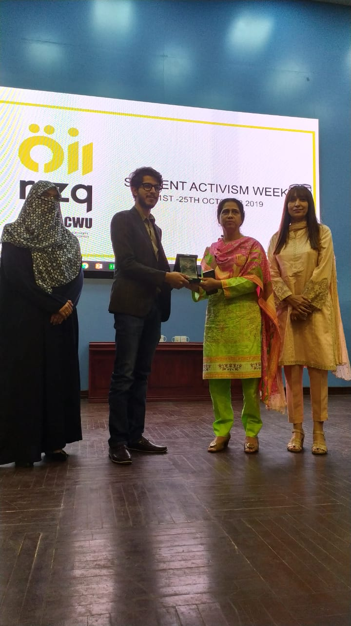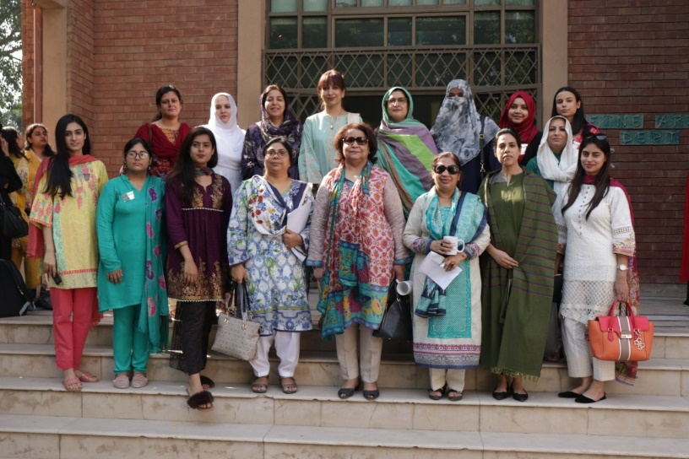
The Rizq ASAP LCWU Program organized and hosted a ‘Student Activism Week 2019’ from the 21st to 23rd of October 2019, under supervision of Department of Professional Studies and the Directorate of Student Affairs. The series of events included talks, seminars, competitions, student presentations and an exhibition. Dr. Asma Shahid Kazi, CoD Department of Professional Studies, Ms. Shagufta Moghal (Rizq ASAP LCWU Advisor), Department of Professional Studies and Ms. Bushra Nadeem, Director Student Affairs were the focal persons for the events. Students from all over the university participated in the Poster Competition, Speech Competition Audition, National Songs Competition and Cultural Dance Competition.
SDG 3: Good health and well-being for people

Dengue Awareness Walk Report, 18th Sep, 2019

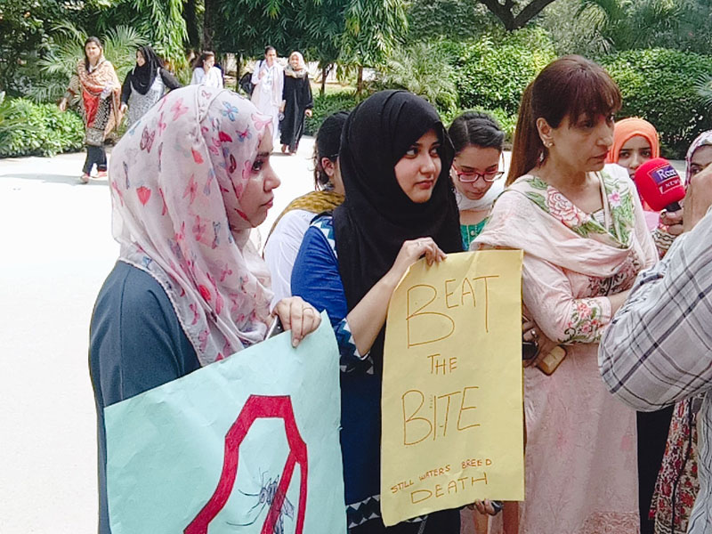
Lahore College for Women University arranged a dengue awareness walk as per the instructions of Punjab Government within campus premises in collaboration with Director Student Affairs, Dengue Committee and Student Council on Wednesday, 18th September, 2019. Walk was led by Worthy Vice Chancellor LCWU Prof. Dr. Bushra Mirza along with university administration, faculty members and students.

One-Day Awareness Seminar on Breast Cancer Awareness

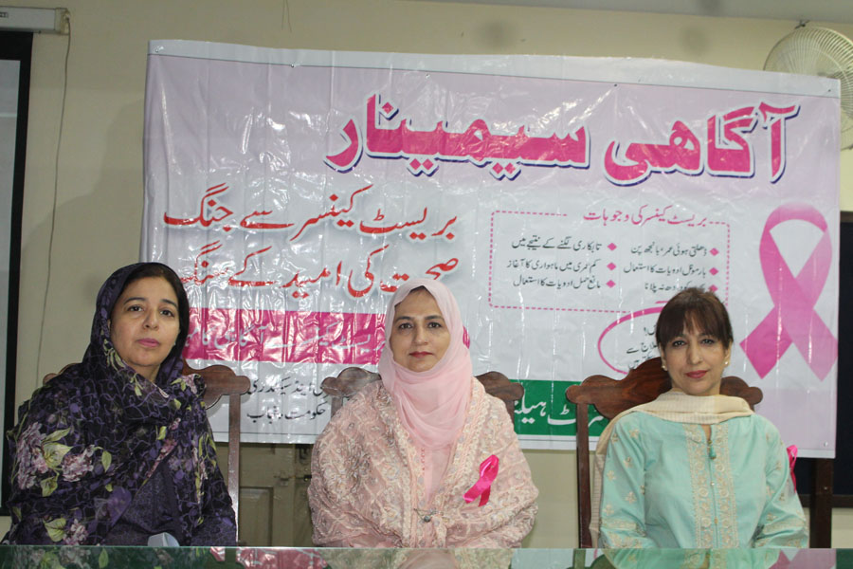

An awareness seminar regarding Breast Cancer Awareness Month (October 2019) conducted at Lahore College for Women University, organized by District Health Authority and Prevention & Control of Non-Communicable Diseases Program, Punjab in collaboration with Gender and Development Studies Department, LCWU in the student service center (Seminar Hall) on 21-10-2019 at 10:00 am. Dr. Subha Malik, Chairperson Gender and Development Studies welcomed and introduced the speaker guests. Ms. Tahira Mariam (District Health Education Officer) discussed the Risk Factrs, signs and symptoms for early detection of breast cancer.

Autism Awareness in collaboration with Autism Spectrum Disorder Welfare Trust( ASDWT)

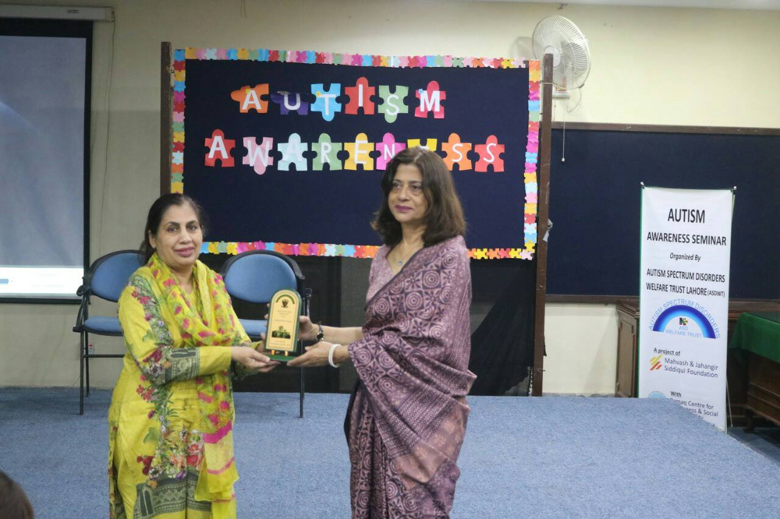

Psychological Society LCWU organized a Seminar on " Autism Awareness" in collaboration with Autism Spectrum Disorder Welfare Trust( ASDWT) on October 17' 2019. The focal persons for the seminar were Ms.Tehziba Kousir ( lecturer) and Dr.Amina Obaid Khawaja ( AP).The seminar opened with recitation of holy Quran following the welcome address by prof.Dr.Talat Sohail( COD' department of Applied Psychology).
SDG 4: Quality education
Impact:
Three-days workshop on “New Curriculum of Zoology” organized by Prof. Dr. Farkhanda Manzoor, Dr. Saima Sharif and Dr. Farah Ashfaq Department of Zoology, LCWU. Learning Innovation Division (LID) of HEC, in collaboration with Lahore College for Women University (LCWU), Lahore organized a 3-days workshop on “New Curriculum of Zoology” during April 22 – 24, 2019. HEC invited 23 faculty members from LCWU, Shaheed Benazir Bhutto University, Sheringal, Dir Upper, Khyber Pakhtunkhwa, University of Sargodha, National University of Medical Sciences, Bacha Khan University, Charsadda, The Women University Multan, University of Agriculture, Multan, Sindh Agriculture University, Tandojam, University of Kotli, Azad Jammu & Kashmir, Quaid-e-Azam University, Islamabad, Shah Abdul latif University, Khairpur, Sindh, University of the Punjab, Lahore, University of Malakand, Abdul Wali Khan University, Mardan to participate in this workshop.

1st International Collaboration between International Islamic University, Malaysia and Lahore College for Women University, Lahore Pakistan for the Development of Arabic Language (28th-31st Oct, 2019)

This 1st international collaboration between IIUM and LCWU for the development of Arabic language is a first step towards achieving the objectives set by the vision 2020 of LCWU which urges to improve quality of Higher Education through Faculty Development and Internationalization. It is a moment of great pride for the Arabic department to play its role in the development of LCWU through this series of significant events. We hope to have more of such activities and other joint academic ventures for the betterment of academic and research environment of LCWU and for the promotion of Arabic language in the global context.

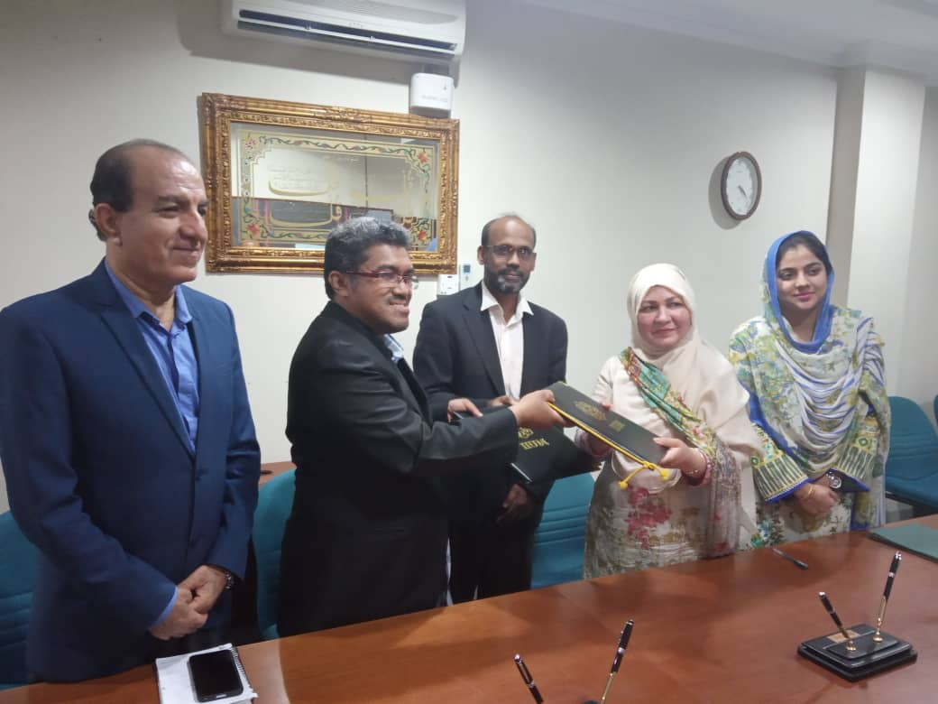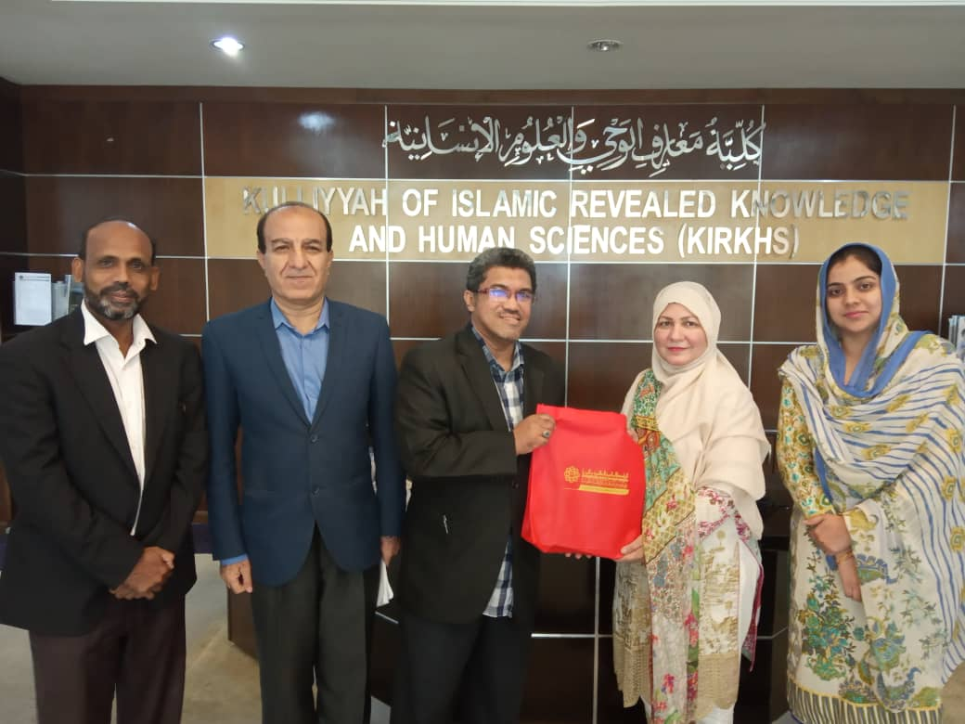

SDG 5: Gender equality

Three Days Workshop on “Gender Analysis”

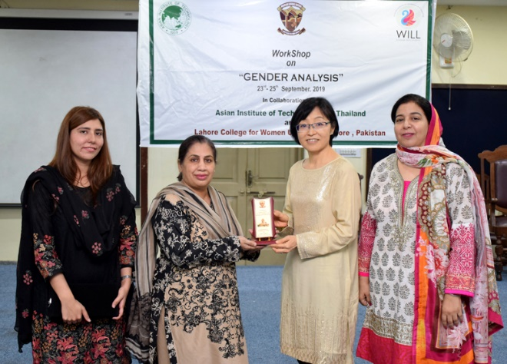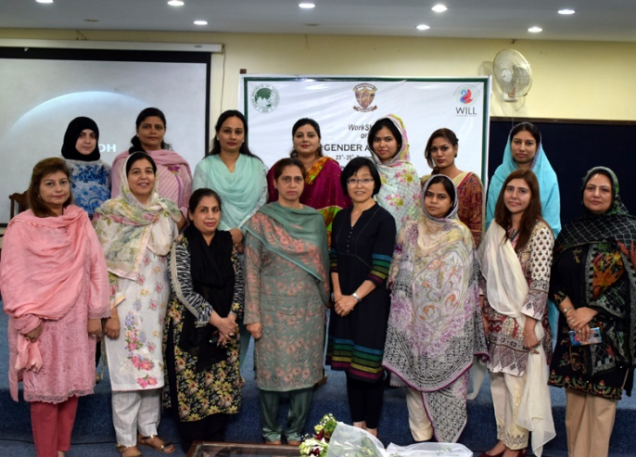

23rd to 25th September 2019 : The Department of Gender & Development Studies, Lahore College for Women University” developed linkages & research collaboration under the HEC funded project “Strengthening of Faculties of LCWU” with Asian Institute of Technology, Thailand. To proceed further with linkages program, Prof. Kyoko Kusakabe HOD Development & Sustainability at Asian Institute of Technology, Thailand visited Department of Gender and Development Studies, LCWU for training of GDS faculty and students. Prof. Kyoko Kusakabe delivered lectures on Three Days’ Workshop on “Gender Analysis” 23rd to 25th September 2019 organized by Department of Gender & Development Studies, LCWU.
Impact example:

One-Day Teachers Training Workshop “On increasing child sexual abuse in Pakistan and Role of Academia in training adolescents about self-protection”
Monday 26th August 2019:Department Gender and Development studies LCWU organized One-Day Teachers Training Workshop on increasing child sexual abuse in Pakistan and role of academia in training adolescents about self-protection, in collaboration with Pakistan Girls Guide Association and sponsored by Creative Alley on Monday 26th August 2019. Almost 40 plus people attended in workshop including participants, volunteers, internees, Pakistan Girls Guide staff members, executives and trainers of workshop.
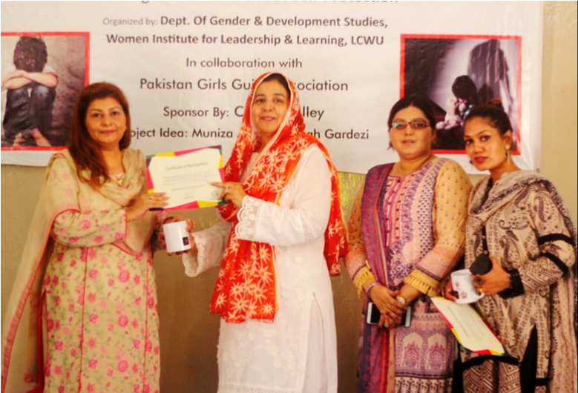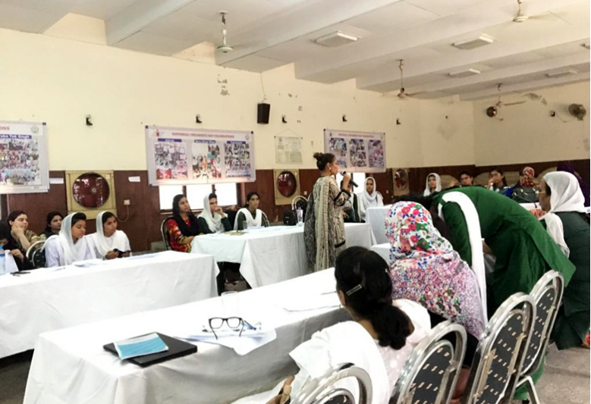

International Women’s day Celebration Intercollegiate performing art competition

March, 07, 2019: Women Institute for Leadership and Learning (WILL) of Lahore College for Women University (LCWU) in collaboration with strengthening participatory organization (SPO) has organized an Inter-departmental debating competition activity pertaining to celebrations of International Women’s day, 2019. This activity aims to make a consensus among young girls about raising their voices against increasing gender imbalances in society, to make them aware about the importance of gender balanced roles for the sake of achieving global sustainable development. Approx. 12 to 15 students have participated in this competition. Dr Shehla Ahmed Assistant Professor Department of gender and development studies has shared the background of the celebrations of International Women’s day and its 2019 theme with audience. Mr Shahnawaz Khan, Regional Head (SPO) Lahore has shared the working and efforts of this organization regarding gender empowerment. Miss Hifza Mahmood, Focal person SPO has shared the importance of gender and development studies students’ active involvement in maintaining gender balance in society. Dr Subha Malik HOD Gender and development studies in her closing remarks has appreciated the participation of debaters and showed her gratitude towards SPO for collaborating in this event and thanks to judges Ms Iram Shahid HOD Social work, Dr Qamar Fatima HOD Political Science and Dr Faleeha HOD of Persian.
Intercollegiate performing art competition
March, 08, 2019: Women Institute for Leadership and Learning (WILL) of Lahore College for Women University (LCWU) in collaboration with strengthening participatory organization (SPO) has organized an Intercollegiate performing art competition activity pertaining to celebrations of International Women’s day, 2019. This activity aims to make a consensus among youngster about raising their voices against increasing gender imbalances in society, to make them aware about the importance of gender balanced roles for the sake of achieving global sustainable development. Teams from Kinnard College, Samanabad College, and University of the Punjab and Lahore Garrison University have participated in this competition. Ms Muniza Javed from Women Institute for Leadership and Learning (WILL) shared the background of the celebrations of International Women’s day and its 2019 theme with audience. Mr Shahnawaz Khan, Regional Head (SPO) Lahore shared the working and efforts of this organization regarding gender empowerment. Ms Hifza Mahmood, Focal person SPO shared the importance of gender and development studies students’ active involvement in maintaining gender balance in society. The team from University of The Punjab got 1 st position, Kinnaird College for women team got 2nd position and Samanabad College for Women got 3 rd position in the competition. Overall, all the teams gave their best performances. Dr Subha Malik HOD Gender and development studies in her closing remarks appreciated the participation of debaters and showed her gratitude towards SPO for collaborating in this event and thanks to judges Ms Fareeha Basit HOD English Department, Ms Bushra Nadeem Director Student’s affairs and Dr Anjum Zia HOD Mass Communication.
RESEARCH

Three Days Workshop on “Gender Analysis” 23rd to 25th September 2019
The Department of Gender & Development Studies, Lahore College for Women University” developed linkages & research collaboration under the HEC funded project “Strengthening of Faculties of LCWU” with Asian Institute of Technology, Thailand. To proceed further with linkages program, Prof. Kyoko Kusakabe HOD Development & Sustainability at Asian Institute of Technology, Thailand visited Department of Gender and Development Studies, LCWU for training of GDS faculty and students. Prof. Kyoko Kusakabe delivered lectures on Three Days’ Workshop on “Gender Analysis” 23rd to 25th September 2019 organized by Department of Gender & Development Studies, LCWU.
SDG 6: Clean water and sanitation
Impact:

Launching Ceremony of Clean & Green Campus Campaign
March 21, 2019: Women Institute for Leadership and Learning (WILL) of Lahore College for Women University (LCWU) in collaboration with strengthening participatory organization (SPO) has organized a launching ceremony of clean &amp; green campus campaign pertaining to celebrations of International Water Day. This campaign aims to educate students about the importance of clean and green environment, the need of safe and clean water and about tackling the water crisis by addressing the reasons why so many people are unable to get access to safe and clean water. We have renowned and reputed guest speakers from different organizations who shared their valuable views. Ms Nayab Javed from Women Institute of Leadership and Learning (WILL) shared the importance of World Water Day. Guest Speakers Mr. Shahnawaz Khan, Regional Head, SPO, Mr. Farakat Ali, Provincial Coordinator, Water Aid Program, Ms Uzma Kardar, Member National Assembly, Dr. Anjum Zia, General Body Member, SPO/ HOD, Mass Communication Department, LCWU shared their views with us. Then there was an open discussion session and at the end Dr. Talat Sohail Director WILL in her closing remarks shared her views about the importance of International water day, showed her gratitude towards SPO for collaborating in this event and thanks to all honorable guest speakers.
SDG 7: Affordable and clean energy
SDG 8: Decent work and economic growth
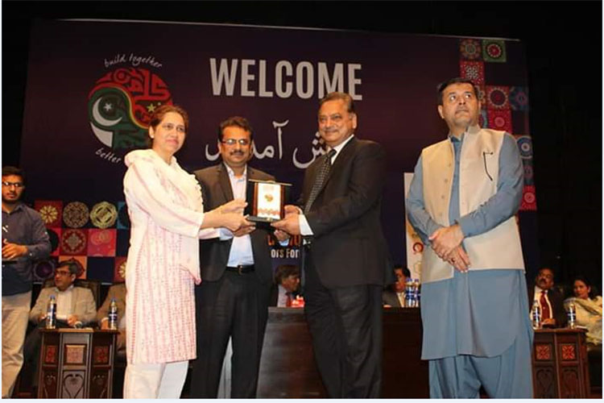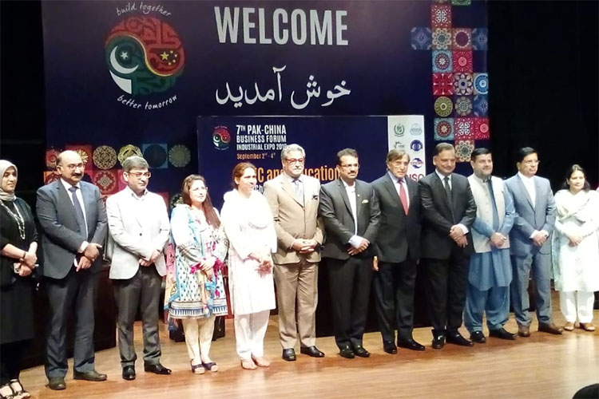
SDG 9: Industry, Innovation, and Infrastructure
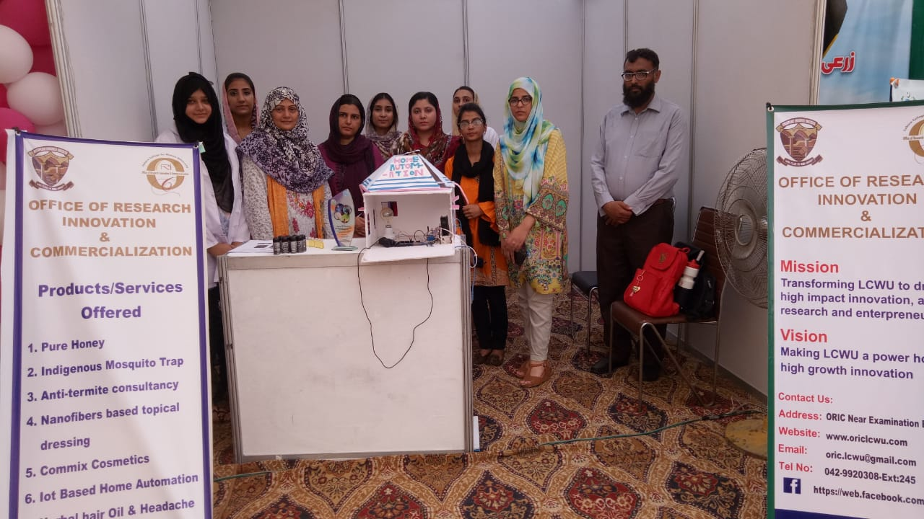
ORIC-LCWU showcased products of Biotechnology, Pharmacy, Electrical Engineering Departments in Conference Cum Expo (23rd - 24th September 2019) at PCSIR Laboratories Complex, Lahore. The LCWU stall was visited by a large number of participants which showed deep interest in various products of above-mentioned departments especially homes automation project by Dr. Taskeen, Assistant Professor from the Electrical Engineering Department. Chief Guest of the event lauded the efforts of LCWU in focusing on applied research. It is pertinent to mention that LCWU participated in PCSIR exhibition due to the keen interest of Director ORIC Prof. Dr. Farkhanda Manzoor.

SoCreative Hackathon | LCWU Startup Cohort-2

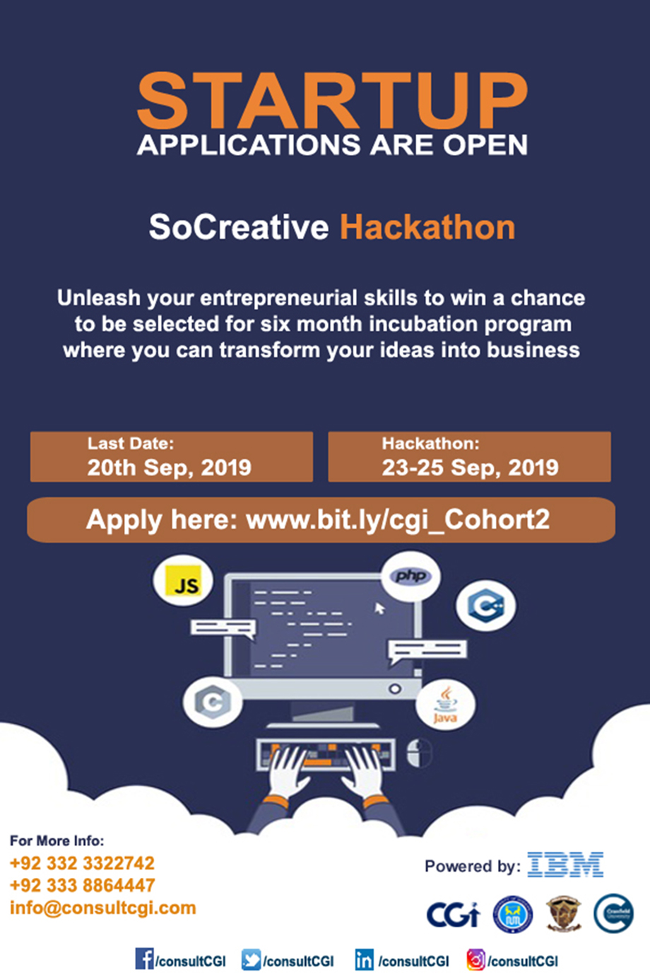

SDG 10: Reducing inequalities

Gender Dimension of Pakistan’s Macro Economic Development

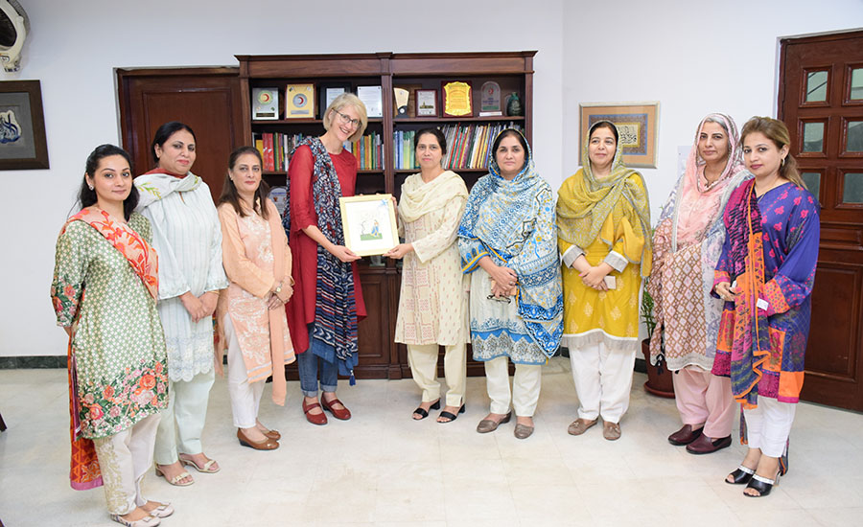

Faculty Development Centre, DFDI of LCWU has organized a international seminar on “Gender Dimension of Pakistan’s Macro Economic Development” in October, 2019 for the faculty and students of LCWU which was conducted by an international speaker Dr. Karin Astrid Siegmann, who is a Senior Lecturer of Labour and Gender Economics at International Institute of Social Studies of Erasmus University Rotterdam, Netherlands.
SDG 11: Sustainable cities and communities

Technical Sessions in Architecture Department- Fall Semester 2019

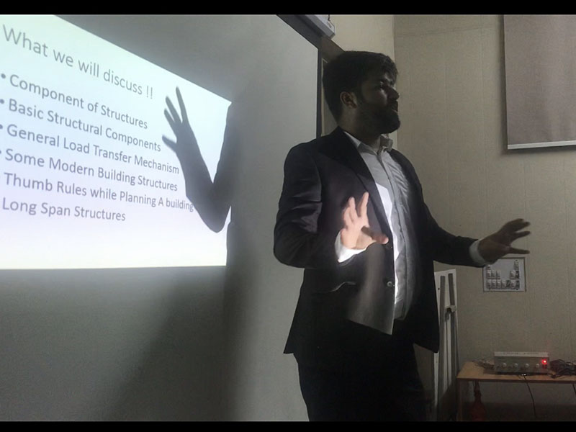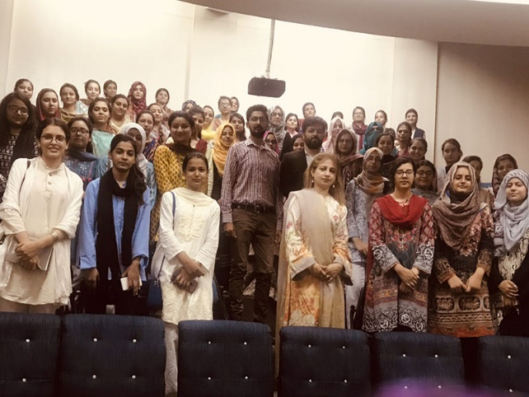

In accordance with the requirement of curriculum in Theoretical, Practical and Design studio courses in Architectural Education, a series of technical sessions throughout the Fall Semester -19 has been scheduled. The objective of these sessions is to enhance students ‘understanding and grip on relevant courses with a blend in resource i.e. academia and field practitioners in a right amalgam. The media of sessions will vary from Seminars , Workshops, Field Excursions/Surveys to On-Line / Collective Competitions. In regard to Architectural Design Studio-VII Project “ Regeneration of Old Lahore Markets around Lahore Fort” , the baseline for Conservation and Structural Design Techniques , Engineer Haris Hameed was invited to conduct the session. Mr Haris is a Civil Engineer with Bachelors in Civil Engineering from UET , Lahore-MS Structural Engineering NUST Islamabad and PhD Scholar in Structures , FAST NU Lahore . He is also Technical Executive Irtiqa Designs. He is currently working on Conservation and Structural Works of Maryam Zamani Mosque.
In a 2-hour session Mr Haris explained in detail planning and implementation being executed in various conservation and regeneration projects of Heritage sites; in an incorporated application to students queries. A score weighing quiz was held as while concluding the session. Lecturer Architecture Department Mr Noman Iqbal moderated the session; and note of Thanks was delivered by Ms Yasmeen Maan , Incharge Architecture Department.

Pakistan-Japan Joint Seminar on “Disability & Development” held at LCWU

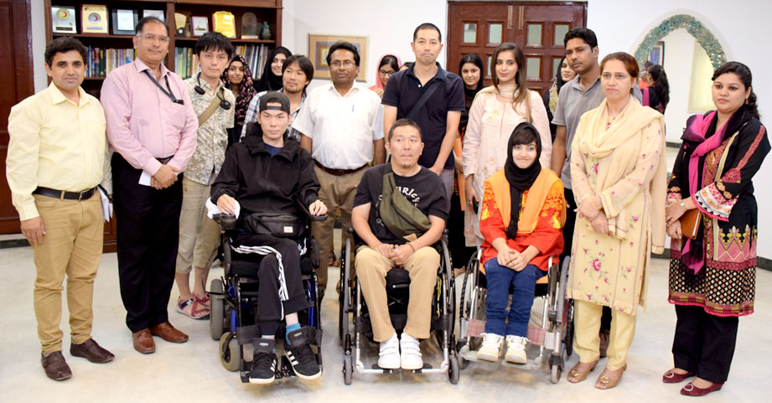

A delegation of Mainstream Association Japan visited LCWU and met with the Vice Chancellor, Prof. Dr. Bushra Mirza on 26th August 2019. Prof. Dr. Intesar Ahmed, Dean Faculty of Engineering and Technology and Prof. Dr. M. Atiq ur Rahman, Chairperson of CRP Department were also present. The Japanese delegation was led by Mr. Koji Kawazoe and Mr. Misayuki Hirata, Mr. Kenchi Murata, Mr. Takeshi Kotani, Mr. Junichi Kimura from Mainstream Association, Japan. Mr. Rizwan, Mr. Mehmood, Ms. Anam Khan and Dr. Esha Amin from Milestone Society of the Special Persons served as interpreters. The guests of the seminar shared experience of independent living in Japan with the students of City and Regional Planning Department, LCWU. The students showed keen interested in planning system of Japan for barrier free mobility of physically challenged persons.
SDG 12: Responsible consumption and production
SDG 13: Climate action
SDG 14: Life below water
Impact:
Lecture of Prof. Dr. Naeem Khan, Vice Chancellor, University of Baltistan, Skardu
Prof. Dr. Naeem Khan, Worthy Vice Chancellor, University of Baltistan, Skardu visited Lahore College For Women University on April 12, 2019. ORIC, LCWU, Prof. Dr. Farkhanda Manzoor and Dr. Shafaq Fatima organized his lecture entitled “Professional Development in Education” for students of Zoology. In his lecture, he discussed the objectives, policies and structure of University of Baltistan in growth of education in these under developed areas. He highlighted the scope of research in the various fields of Zoology in Gilgit Baltistan particularly in Fisheries and Aquaculture. He encouraged female students to come forward and practically perform in development of the country. He presented examples of females entrepreneurs from the region of Gilgit Baltistan to motivate the students. Moreover, he advised students to look for external funds to materialize their research ideas, attending conferences and trainings for broadening their horizons and establish professional network. Students particularly took interest in the lecture and asked different questions to seek guidance. Later, he visited the first Aquaculture facility of LCWU with Dr. Shafaq Fatima and appreciated this initiative for progress of Fisheries & Aquaculture in Asia’s largest women university.

Inaguration Ceremony of First Technology Development Fund project in LCWU
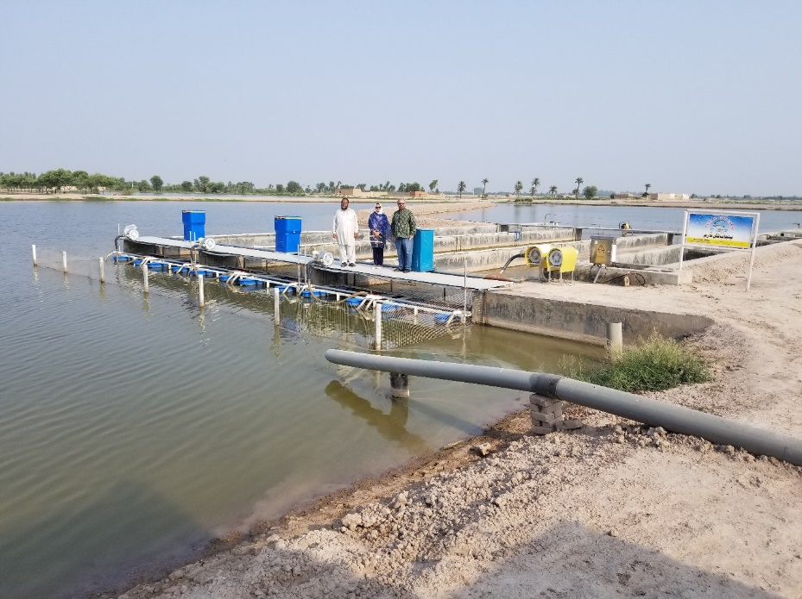
Inauguration Ceremony of First Technology Development Fund project on “In-Pond Raceway System (IPRS) is a fish culture” in LCWU on 4th August, 2019 by Punjab Fish Farm and Lahore College for Women University, Lahore.
In-Pond Raceway System (IPRS) is a fish culture technology developed to increase production efficiency and yield. Few years back, this technology was developed by Auburn University, USA and in recent past years Chinese Aquaculture Industry adopted this IPRS technology with support of Chinese Government. In Pakistan, this innovative technology is first time introduced in Southern Punjab by collaboration of Higher Education Commission of Pakistan, SoyPak, Pvt. Ltd., Punjab Fish Farm and Lahore College For Women University, Lahore, which has brought solutions of major problems of Aquaculture industry of Pakistan which include less production per unit area, high cost, low FCR, wastage of water, poor aeration, challenged water quality and risk to natural resources.
Introduction of IPRS technology in Pakistan materializes the prime minister’s vision for development of Fisheries and Aquaculture industry in Pakistan. This first IPRS commercial and research demo site in Pakistan has been established with partial funds provided under Technology Development Fund of Higher Education Commission. Technical Consultancy by R.S.N. Janjua (SoyPak, Pvt. Ltd.) while Kamran Maqsood (Punjab Fish Farm) is the first progressive fish farmer who adopted this technology. Dr. Shafaq Fatima from Department of Zoology (Aquaculture), Lahore College For Women University, Lahore is the principal investigator in the project with Co-PI, Prof. Dr. Farkhanda Manzoor.
Inauguration ceremony of first IPRS in Pakistan was held at Farmers Field Day on Sunday, August 4, 2019 in Haveli Koranga, District Khanewal. Respected Senator Rana Mahmood Ul Hassan (Member of Senate Standing Committee of Textile and Commerce) was the Chief Guest and he inaugurated the IPRS site and declared it a remarkable and history changing occasion for Aquaculture industry in Pakistan. He hoped that other farmers will also adopt this new and innovative technology.
SDG 15: Life on land
SDG 16: Peace, justice and strong institutions
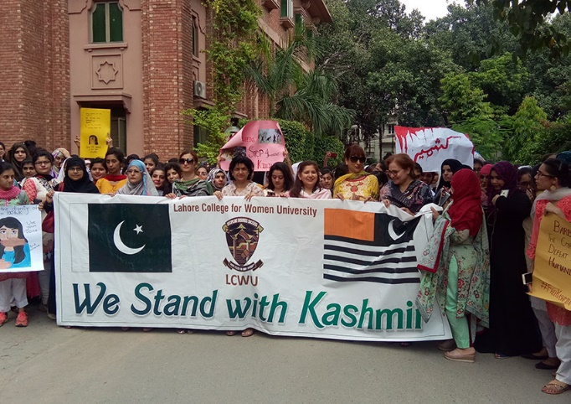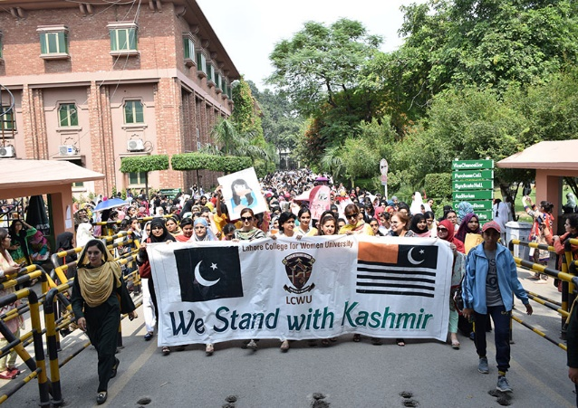
As per the directions of the Government of Pakistan, Lahore College for Women University organized a walk to show solidarity with Kashmir, under the supervision of Director Student Affairs on Friday, 20th September, 2019 from 12:00pm to 12:30pm on the service road outside the campus. Registrar LCWU, Deans, Directors, CODs, faculty members, administrative staff and students participated in the walk.
SDG 17: Partnerships for the goals

